At Harborne Primary School the phrase ‘Happy Pupils Succeed' embodies our philosophy. We see ourselves as a learning community where everyone works together on behalf of the children in order to maintain a happy and caring ethos in which children can achieve high standards and be successful learners.
Harborne Primary School was established in 2000 after the amalgamation of the Infant and Junior Schools, both of which had been at Station Road for 100 years.
More recently the school expanded in 2019 to include the Annex, located on the Court Oak Road approximately a mile away from the Station Road site.

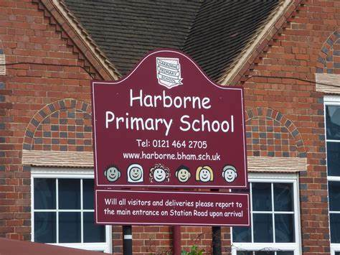
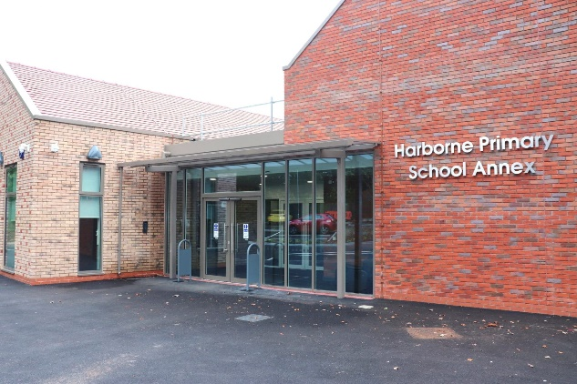

Curriculum Purpose: Why Study Phonics?
Why do we teach Phonics?
Teaching children to read is an essential part of their learning. Reading is a skill that helps to develop vocabulary and improve understanding of words. In synthetic phonics lessons, children learn the relationship between letters and sounds. Teaching them to recognise the sounds each letter makes and how to put them together, enables them to read. It also helps with spelling as they learn how to break up words into sounds, in order to spell them. The idea that surrounds synthetic phonics is that once they are comfortable with the letters and sounds that make up words, children should even be able to read ‘nonsense’ words that don’t actually exist in the English language.

National Curriculum (what do we want learners to be able to know and do by the time they leave Harborne Primary School?).
By the end of each key stage, pupils are expected to know, apply and understand the matters, skills and processes specified in the relevant programme of study:

In the Early Years Foundation Stage, children should be able to say a sound for each letter in the alphabet and at least 10 digraphs. They should be able to read words consistent with their phonic knowledge by accurately blending. Teacher should ensure that children are able to read aloud simple sentence and books which are consistent with their phonic knowledge. Children should also be able to read some common exception words.
During year 1, teachers should build on work from the Early Years Foundation Stage, making sure that pupils can sound and blend unfamiliar printed words quickly and accurately using the phonic knowledge and skills that they have already learnt. Teachers should also ensure that pupils continue to learn new grapheme-phoneme correspondences (GPCs) and revise and consolidate those learnt earlier. The understanding that the letter(s) on the page represent the sounds in spoken words should underpin pupils’ reading and spelling of all words. Alongside this knowledge of GPCs, pupils need to develop the skill of blending the sounds into words for reading and establish the habit of applying this skill whenever they encounter new words. This will be supported by practice in reading books consistent with their developing phonic knowledge and skill and their knowledge of common exception words. Pupils should be helped to read words without overt sounding and blending after a few encounters. Those who are slow to develop this skill should have extra practice.
By the beginning of year 2, pupils should be able to read all common graphemes. They should be able to read unfamiliar words containing these graphemes, accurately and without undue hesitation, by sounding them out in books that are matched closely to each pupil’s level of word reading knowledge. They should also be able to read many common words containing GPCs taught so far [for example, shout, hand, stop, or dream], without needing to blend the sounds out loud first. Pupils’ reading of common exception words, should be secure. Pupils will increase their fluency by being able to read these words easily and automatically.

How are Fundamental British Values taught from _______?
Schools should promote the fundamental British values of democracy, the rule of law, individual liberty, and mutual respect and tolerance of those with different faiths and beliefs

Curriculum Rationale: Why Study Phonics in this way?

How are phonics lessons delivered at Harborne Primary School?
We use Twinkl Phonics as our systematic, synthetic phonics programme (SSP). It is high quality and robust in its purpose. With a clear, structured progression through the programme, it allows all of our pupils to meet or exceed the expected standard.
Phonics is taught daily to all children in EYFS and key stage 1. Within reception, phonics sessions will increase in length over the year. By the end of reception, children spend up to an hour a day consolidating previous learning, learning new content and practising and applying what they have learnt. This will consist of a mixture of carpet time and follow-up activities. Phonics will also form part of their continuous provision for children to access following their discrete phonics lesson. In year 1 and 2, phonics lessons will last about 30 minutes each day. Children will then take part in a 30 minutes reading sessions which will use and consolidate the skills they have been taught. Children identified as not making the expected progress will be identified early and will receive additional phonics interventions either through same-day ‘keep up’ interventions or in small focus ‘catch up’ groups following an assessment of their needs

Some children may continue to need discrete phonics sessions in key stage 2. If this is the case, they will receive regular 20 minute intervention sessions, delivered using the Twinkl Phonics Codebreakers interventions. Children will be regularly assessed to ensure they are receiving phonics teaching at the correct level.

What is the impact?

Phonics Curriculum Aims (end points)

What are the aims, endpoints, of specific stages of the curriculum?
In Reception children will have been taught level 2, 3 and 4:
By the end of Level 2:
• identify the phoneme when shown any Level 2 grapheme;
• identify any Level 2 grapheme when they hear the phoneme;
• orally blend and segment CVC words;
• blend sounds to read VC words, such as, ‘if’, ‘am’, ‘on’ and ‘up’;
• segment VC words into their sounds to spell them (using magnetic letters);
• read the tricky words: the, to, I, no, go

By the end of Level 3, children will have had the opportunity to
• say the phoneme when shown all or most Level 2 and Level 3 graphemes;
• find all or most Level 2 and Level 3 graphemes, from a display, when given the phoneme;
• blend and read CVC words (single-syllable words consisting of Level 2 and Level 3 graphemes);
• segment and make a phonetically plausible attempt at spelling CVC words (single-syllable words consisting of Level 2 and Level 3 graphemes);
• read the tricky words - he, she, we, me, be, was, my, you, here, they, all, are & spell the tricky words - the, to, I, no, go;
• write each letter correctly when following a model.

By the end of Level 4, children will have had opportunities to:
• give the phoneme when shown any Level 2 or Level 3 grapheme;
• find any Level 2 or Level 3 grapheme when given the phoneme;
• blend and read words containing adjacent consonants as well as segment and spell words containing adjacent consonants;
• read the tricky words - some, one, said, come, do, so, were, when, have, there, out, like, little, what & spell the tricky words - he, she, we, me, be, was, my, you, here, they, all, are;
• write each letter, usually using the correct formation; • orally segment words into phonemes.

In Year 1 children will have been taught level 5:

By the end of level 5, children will have the opportunity to:
• give the phoneme, when shown any grapheme that has been taught;
• for any given phoneme, write the common graphemes;
• apply phonics knowledge and skills as the primary approach to reading and spelling unfamiliar words that are not completely decodable;
• read and spell phonically decodable two-syllable and three-syllable words;
• read automatically all taught tricky and common exception words;
• accurately spell all the Level 2, 3 and 4 tricky words and most of the common exception words for reading;
• form each letter correctly;
• use alternative ways of pronouncing and representing the long vowel phonemes.
In Year 2 children will have been taught level 6:

By the end of Level 6, children will have had opportunities to:
• read accurately most words of two or more syllables;
• read most words containing common suffixes;
• read most common exception words;
• read most words accurately, in age-appropriate books, without overt sounding and blending, fluent enough to allow them to focus on their understanding rather than on decoding individual words;
• sound out most unfamiliar words accurately, without undue hesitation;
• segment spoken words into phonemes and represent these by graphemes, spelling many of these words correctly and making phonetically plausible attempts at others;
• spell most common exception words correctly

Children identified as not making the expected progress will be identified early and will receive additional phonics interventions either through same-day interventions or in small focus groups following an assessment of their needs.

